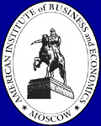
`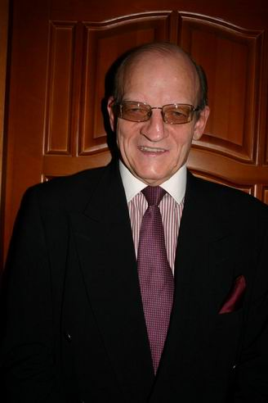

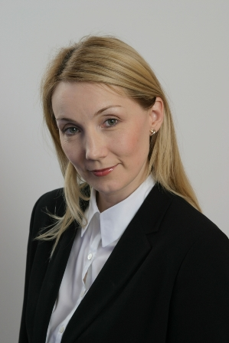
Art Franczek, president of AIBEc and professor of Accounting.
Voted Professor of the Year by AIBEc Students
Art is currently the president of The American Institute of Business and Economics in Moscow (an English language MBA program that was founded in 1989). He holds degrees in History and Political Science in addition to an MBA, CPA and a Masters of Taxation. In addition to managing AIBEc he teaches courses in IFRS, Taxation and Cost Management. He has served as a consultant for the Russian Central Bank (IAS 39), the World Bank(on implementing IFRS in Russia), The Bank of Albania (implementing IFRS and IAS 39) and has written many articles on IFRS, Customs and Taxation issues in addition to a book on IFRS. Art is also co-chair of the Customs Committee at Am Cham and was awarded co-chair of the year in 2002 and 2011 . He also coached AIBEc students to 8 first place awards in the 10 years of Am Cham MBA case competitions.

Prior to coming to AIBEc Art served as a business consultant in Togliatti after working for many years as a Corporate Tax Manager for a Fortune 1000 company.

